Assignment 1: Student Spending Simulation and Analysis
Group Analysis
2026-03-02

The overview of this assignment is to investigate how much money a student who is at the University of Free State would need to have monthly. To do this, we will need to simulate two set of data on R, which will be Observational then from the observational, we will group our data into categories to create our experimental dataset. After all of that will have to do some analysis of the data and comparison of the two data sets. Our dataset includes 7 explanatory variables, including distance from campus, number of hours spent studying per month, number of social outings per week, whether the student has financial literacy, the type of accommodation they reside in, and whether they are self-funded or have a bursary, which can be private or NSFAS, and gender. Then, finally, our dependent variable will be the amount.
Details of the Variables
- Accommodation
This will be a categorical variable, consisting of On-campus res, Off-campus res, and Apartment. According to research, when it comes to prices, on-campus accommodation is the cheapest, followed by off-campus accommodation, and then finally the most expensive one, which is the Apartments. The code for this will be as follows:
- Distance from campus
This will be our continuous variable, giving us the distance one has to travel to classes or the campus daily. The more the distance they have to travel, the more they will spend money on bus fares, bolt, cabs, or even gas for students who may own cars. It costs around R10 per KM in Bloem then R20 will be our coefficient source from newcastillian.
- Hours spent studying
This variable, which will be a continuous variable, will show us how can the number of hours a particular person will spend studying in a month. This is a variable that should have a negative relationship with the number of outings that one will experience, as in the more you study, the less time you have to go out, and the less you study, the more time you have to go out. The code that is used for this case is as follows:
- Number of social outings
The number of times one goes out can greatly influence how much money a person will have spent by the end of the month. In this case, we made it so that a single outing should cost a minimum of R286 according to Trekzone. And as previously stated, it has a negative relationship with the amount of time a person spends studying. The code that was used is as follows:
- Financial literacy
This continuous variable is a rating system that will give us a rating on a scale of 0-100 of how financially literate a person is, with 0 being low financial literacy and 100 being high financial literacy. The high one is, the more likely their expenditures will be low as they possess better knowledge on how to properly come up with a budget plan and save better.
- Type of funding

# This hidden chunk sets global options to ensure code and output are both visible
knitr::opts_chunk$set(echo = TRUE, warning = FALSE, message = FALSE)
set.seed(2026)
n <- 4860
# 1. Independent Variables
x_gender <- sample(c(0, 1), n, replace = TRUE)
x_funding <- sample(c(0, 1), n, replace = TRUE, prob = c(0.4, 0.6))
x_accommodation <- sample(c(1, 2, 3), n, replace = TRUE, prob = c(0.3, 0.5, 0.2))
# Distance: Continuous KM
x_distance <- ifelse(x_accommodation == 1, runif(n, 0.01, 0.49), runif(n, 1.5, 15))
x_distance <- round(x_distance, 2)
# Financial Literacy & Study Hours
x_fin_lit <- round(pmax(pmin(rnorm(n, 55, 12), 100), 0), 2)
x_study_hrs <- round(runif(n, 9, 42) * 4, 2)
# Social Outings (Correlation: Literacy and Study Hours reduce outings)
lambda_outings <- pmax(1, 14 - (0.05 * x_study_hrs) - (0.06 * x_fin_lit))
x_outings <- rpois(n, lambda = lambda_outings)

True Model
$$Y=β_{0}+β_{1}+β_{2}\left(Distance\right)+β_{4}\left(outings\right)+β_{5}\left(Financial literacy\right)+β_{6}\left(Funding\right)+ϵ$$
In the code below, we have a way in which the y variable is being generated with the help of the true mode. Our true model only involves 5 out of the 7 variables; the number of hours spent studying does not influence the model directly, while Gender doesn’t have any form of influence hance why not included as students spend money irrespective of their gender but their preference.
# 2. Generating Spending (Y) with high noise for 35-50% R-squared
beta_0 <- 2200
acc_adj <- ifelse(x_accommodation == 2, 850, ifelse(x_accommodation == 3, 3200, 0))
# Large SD (1650) ensures the model doesn't explain too much of the variance
epsilon <- rnorm(n, mean = 0, sd = 1650)
# Base spending (Intercept)
beta_0 <- 2200
# Individual effects
# Baseline spending
beta_funding <- 500 # NSFAS increase
beta_dist <- 25 # Cost per KM
beta_lit <- -12 # Savings per literacy point
beta_outings <- 180 # Cost per social outing
beta_off_campus <- 850
beta_apartment <- 3200
# High noise to ensure R-squared is 35-50%
sigma_noise <- 1650
y_spending <- beta_0 + (beta_funding * x_funding) + acc_adj + (beta_dist * x_distance) +
(beta_outings * x_outings) + (beta_lit * x_fin_lit) + epsilon
# Rounding and realistic constraints (R1200 - R13000)
y_spending <- round(pmax(pmin(y_spending, 13000), 1200), 2)
obs_data <- data.frame(Spending = y_spending, Funding = x_funding,
Accommodation = x_accommodation, Distance = x_distance,
FinLit = x_fin_lit, StudyHrs = x_study_hrs,
Outings = x_outings, Gender = x_gender)
The code gives us a representation of how each variable is distributed
# --- HISTOGRAMS FOR OBSERVATIONAL DATA ---
# Set up a grid of 3 rows and 3 columns
par(mfrow = c(3, 3), mar = c(4, 4, 2, 1))
# 1. Spending (The Outcome)
hist(obs_data$Spending, col = "skyblue", main = "Spending (Y)", xlab = "Rands")
# 2. Funding
hist(obs_data$Funding, col = "lightgreen", main = "Funding Status", xlab = "0 = No, 1 = Yes")
# 3. Accommodation
hist(obs_data$Accommodation, col = "salmon", main = "Accommodation Type", xlab = "1=Res, 2=Off, 3=Apt")
# 4. Distance
hist(obs_data$Distance, col = "gold", main = "Distance to Campus", xlab = "Kilometers")
# 5. Financial Literacy
hist(obs_data$FinLit, col = "plum", main = "Fin. Literacy Score", xlab = "Score (0-100)")
# 6. Study Hours
hist(obs_data$StudyHrs, col = "lightblue", main = "Study Hours", xlab = "Weekly Hours")
# 7. Social Outings
hist(obs_data$Outings, col = "orange", main = "Social Outings", xlab = "Number of Outings")
# 8. Gender (Nuisance)
hist(obs_data$Gender, col = "grey", main = "Gender", xlab = "0 = Male, 1 = Female")
# Reset plotting parameters to default (1x1)
par(mfrow = c(1, 1))
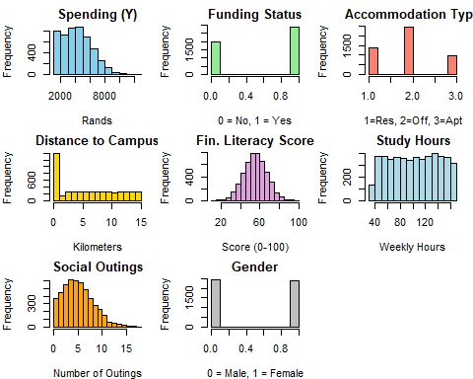
______________________________
# --- SCATTER PLOT MATRIX (OBSERVATIONAL DATA) ---
# Select the key variables for the matrix
# Spending, Distance, FinLit, StudyHrs, and Outings
plot_data <- obs_data[, c("Spending", "Distance", "FinLit", "StudyHrs", "Outings")]
# Generate the matrix
# pch=16 and col=rgb(...) makes the points small and transparent to handle 4860 rows
pairs(plot_data,
main = "Scatter Plot Matrix: Student Spending Drivers",
pch = 16,
cex = 0.5,
col = rgb(0.2, 0.4, 0.6, 0.1),
lower.panel = panel.smooth) # Adds a trend line to the bottom half
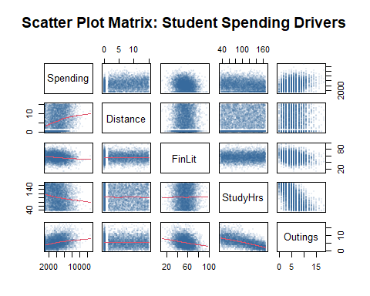
hist(obs_data$Spending, main="Observational: Monthly Student Spending",
xlab="ZAR", col="skyblue", border="white", breaks=40)
abline(v = c(2500, 5000), col = "red", lwd = 2, lty = 2)
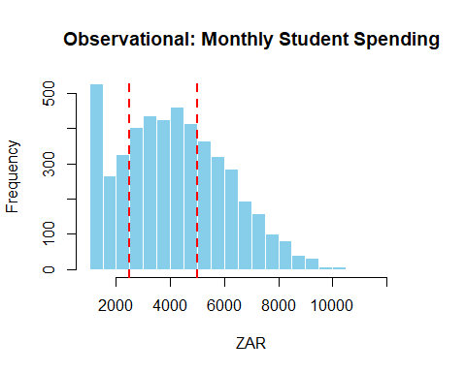
# Relationship between Outings and Spending
plot(obs_data$Outings, obs_data$Spending, main="Outings vs Spending",
xlab="Number of Outings", ylab="Spending (ZAR)", pch=16, col=rgb(0,0,1,0.2))
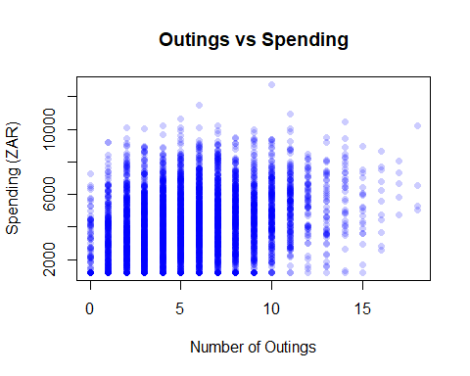

Part 2 of the assignment, where we categorize the continuous variables, which makes it possible to group the data into cells, to create experimental data.
# Create Balanced Grid
exp_grid <- expand.grid(Funding = c(0, 1),
Accommodation = c(1, 2, 3),
Distance = c("Close", "Far"),
FinLit = c("Low", "Moderate", "High"),
StudyHrs = c("Low", "Moderate", "High"),
Outings = c("Low", "Moderate", "High"))
# Replicate to reach N=4860
exp_data <- exp_grid[rep(seq_len(nrow(exp_grid)), each = 15), ]
# Re-simulate Response using categorical effects
dist_eff <- ifelse(exp_data$Distance == "Far", 700, 0)
lit_eff <- ifelse(exp_data$FinLit == "Moderate", -300,
ifelse(exp_data$FinLit == "High", -800, 0))
out_eff <- ifelse(exp_data$Outings == "Moderate", 1000,
ifelse(exp_data$Outings == "High", 2400, 0))
acc_eff <- ifelse(exp_data$Accommodation == 2, 850,
ifelse(exp_data$Accommodation == 3, 3200, 0))
# Apply the same noise level to keep R-squared around 35-50%
exp_data$Spending <- round(beta_0 + (500 * exp_data$Funding) + acc_eff +
dist_eff + lit_eff + out_eff +
rnorm(nrow(exp_data), 0, 1650), 2)
exp_data$Spending <- pmax(pmin(exp_data$Spending, 13000), 1200)
model_obs <- lm(Spending ~ Funding + factor(Accommodation) + Distance +
FinLit + StudyHrs + Outings + Gender, data = obs_data)

Summary of both the Observational and Experimental Data.
# Show coefficients and R-squared
round(summary(model_obs)$coefficients, 2)
## Estimate Std. Error t value Pr(>|t|)
## (Intercept) 2684.55 181.89 14.76 0.00
## Funding 392.82 45.19 8.69 0.00
## factor(Accommodation)2 689.52 74.14 9.30 0.00
## factor(Accommodation)3 2926.29 83.78 34.93 0.00
## Distance 21.51 6.68 3.22 0.00
## FinLit -11.75 1.92 -6.13 0.00
## StudyHrs -1.07 0.73 -1.46 0.15
## Outings 164.30 9.23 17.81 0.00
## Gender 21.25 44.33 0.48 0.63
cat("Observational R-Squared:", round(summary(model_obs)$r.squared, 2))
## Observational R-Squared: 0.4
model_exp <- lm(Spending ~ Funding + factor(Accommodation) + Distance +
FinLit + StudyHrs + Outings, data = exp_data)
# Show coefficients and R-squared
round(summary(model_exp)$coefficients, 2)
## Estimate Std. Error t value Pr(>|t|)
## (Intercept) 2420.89 74.35 32.56 0.00
## Funding 424.50 44.84 9.47 0.00
## factor(Accommodation)2 766.11 54.91 13.95 0.00
## factor(Accommodation)3 3019.34 54.91 54.98 0.00
## DistanceFar 640.36 44.84 14.28 0.00
## FinLitModerate -271.18 54.91 -4.94 0.00
## FinLitHigh -643.02 54.91 -11.71 0.00
## StudyHrsModerate -12.33 54.91 -0.22 0.82
## StudyHrsHigh -9.65 54.91 -0.18 0.86
## OutingsModerate 857.06 54.91 15.61 0.00
## OutingsHigh 2313.03 54.91 42.12 0.00
cat("Experimental R-Squared:", round(summary(model_exp)$r.squared, 2))
## Experimental R-Squared: 0.53
par(mfrow = c(2, 2))
plot(model_exp)
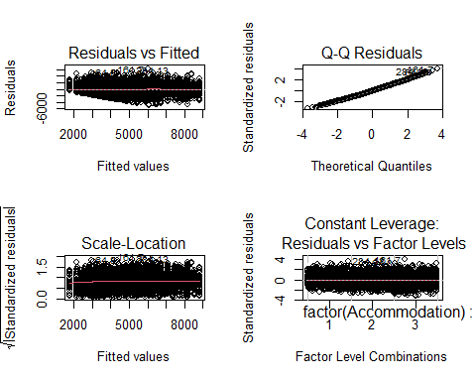

Comparison of True vs. Estimated Parameters (Experimental Data)
This section evaluates the accuracy of the Experimental Model. We compare the coefficients estimated by the model against the discrete categorical effects we programmed into the simulation.
# 1. Extract Estimated Coefficients from the Experimental Model
exp_estimates <- round(coef(model_exp), 2)
# 2. Define the True Betas for the Experimental Categories
# These match the 'dist_eff', 'lit_eff', and 'out_eff' values from Part III
exp_true_values <- c(
"(Intercept)" = beta_0,
"Funding" = beta_funding,
"factor(Accommodation)2" = beta_off_campus,
"factor(Accommodation)3" = beta_apartment,
"DistanceFar" = 700, # Programmed effect for Far vs Close
"FinLitModerate" = -300, # Programmed effect for Moderate vs Low
"FinLitHigh" = -800, # Programmed effect for High vs Low
"StudyHrsModerate" = 0, # Programmed as 0 (indirect effect only)
"StudyHrsHigh" = 0, # Programmed as 0 (indirect effect only)
"OutingsModerate" = 1000, # Programmed effect for Moderate vs Low
"OutingsHigh" = 2400 # Programmed effect for High vs Low
)
# 3. Align and combine into a comparison data frame
# This ensures we only compare variables that exist in the model output
exp_comparison <- data.frame(
Variable = names(exp_estimates),
True_Beta = exp_true_values[names(exp_estimates)],
Estimated_Beta = exp_estimates,
Bias = round(exp_estimates - exp_true_values[names(exp_estimates)], 2)
)
# 4. Display the table in the Word Document
knitr::kable(exp_comparison,
caption = "Experimental Model: Programmed Effects vs. Model Estimates",
row.names = FALSE)
Experimental Model: Programmed Effects vs. Model Estimates
Variable | True_Beta | Estimated_Beta | Bias
(Intercept) | 2200 | 2420.89 | 220.89
Funding | 500 | 424.50 | -75.50
factor(Accommodation)2 | 850 | 766.11 | -83.89
factor(Accommodation)3 | 3200 | 3019.34 | -180.66
DistanceFar | 700 | 640.36 | -59.64
FinLitModerate | -300 | -271.18 | 28.82
FinLitHigh | -800 | -643.02 | 156.98
StudyHrsModerate | 0 | -12.33 | -12.33
StudyHrsHigh | 0 | -9.65 | -9.65
OutingsModerate | 1000 | 857.06 | -142.94
OutingsHigh | 2400 | 2313.03 | -86.97
hhhh
j
# --- COMPARATIVE EXPENDITURE HISTOGRAMS ---
# Set layout for 2 plots side-by-side
par(mfrow = c(1, 2), mar = c(5, 4, 4, 2))
# 1. Observational Spending Distribution
hist(obs_data$Spending,
main = "Observed Spending",
xlab = "Monthly Expenditure (ZAR)",
col = "#5DADE2", # Soft Blue
border = "white",
breaks = 40,
xlim = c(1200, 13000))
# Add reference lines for the R2.5k - R5k target range
abline(v = c(2500, 5000), col = "darkred", lwd = 2, lty = 2)
# 2. Experimental Spending Distribution
hist(exp_data$Spending,
main = "Experimental Spending",
xlab = "Monthly Expenditure (ZAR)",
col = "#58D68D", # Soft Green
border = "white",
breaks = 40,
xlim = c(1200, 13000))
# Add same reference lines
abline(v = c(2500, 5000), col = "darkred", lwd = 2, lty = 2)
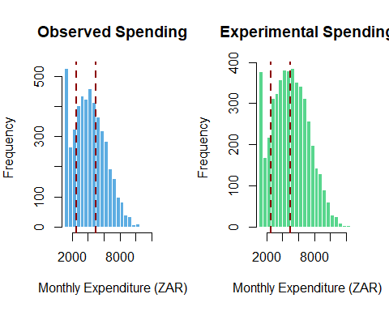
# Reset layout
par(mfrow = c(1, 1))

Distributional Comparison: Superimposed Histogram and Q-Q Plots
This section visually compares the “Expenditure” (Spending) between the Observational and Experimental groups to verify that both simulations reflect the same South African student financial context.
# 1. SETUP: Superimposed Histogram
# Calculate common range for the x-axis
xlim_range <- range(c(obs_data$Spending, exp_data$Spending))
# Create the first histogram (Observational)
hist(obs_data$Spending,
breaks = 40,
col = rgb(0.2, 0.5, 0.8, 0.5), # Transparent Blue
xlab = "Monthly Expenditure (ZAR)",
main = "Superimposed Expenditure Distribution",
xlim = xlim_range,
border = "white")
# Superimpose the second histogram (Experimental)
hist(exp_data$Spending,
breaks = 40,
col = rgb(0.8, 0.2, 0.2, 0.5), # Transparent Red
add = TRUE,
border = "white")
# Add a legend to distinguish the two
legend("topright",
legend = c("Observational", "Experimental"),
fill = c(rgb(0.2, 0.5, 0.8, 0.5), rgb(0.8, 0.2, 0.2, 0.5)),
border = "black")
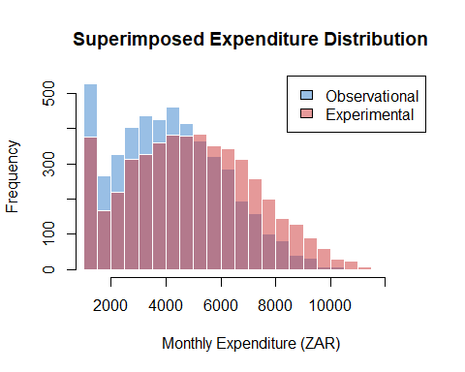
# 2. SETUP: Side-by-Side Q-Q Plots
# These check if the spending follows a normal distribution
par(mfrow = c(1, 2)) # 1 row, 2 columns
# Q-Q Plot for Observational
qqnorm(obs_data$Spending,
main = "Q-Q Plot: Observational",
col = rgb(0.2, 0.5, 0.8, 0.4),
pch = 16)
qqline(obs_data$Spending, col = "darkblue", lwd = 2)
# Q-Q Plot for Experimental
qqnorm(exp_data$Spending,
main = "Q-Q Plot: Experimental",
col = rgb(0.8, 0.2, 0.2, 0.4),
pch = 16)
qqline(exp_data$Spending, col = "darkred", lwd = 2)
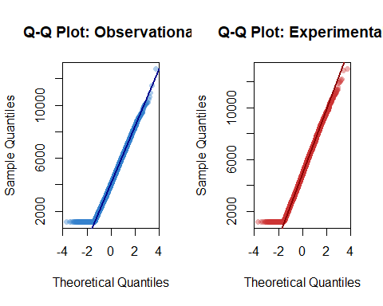
# Reset layout
par(mfrow = c(1, 1))

Model Performance Comparison: R-Squared and Residuals
This table evaluates the overall “Success” of our two models. While we targeted an R-squared of 35-50%, the residuals provide a deeper look into the prediction error of each design.
# 1. Extract R-Squared and Adjusted R-Squared
r2_obs <- summary(model_obs)$r.squared
adj_r2_obs <- summary(model_obs)$adj.r.squared
r2_exp <- summary(model_exp)$r.squared
adj_r2_exp <- summary(model_exp)$adj.r.squared
# 2. Extract Residual Statistics (RSE and Range)
# Residual Standard Error (RSE) represents the "Average Error" in Rands
rse_obs <- summary(model_obs)$sigma
rse_exp <- summary(model_exp)$sigma
# Range of Residuals (Min to Max)
res_range_obs <- range(residuals(model_obs))
res_range_exp <- range(residuals(model_exp))
# 3. Construct the Comparison Table
model_perf_table <- data.frame(
Metric = c("R-Squared (Raw)", "Adjusted R-Squared", "Residual Std. Error (RSE)", "Min Residual", "Max Residual"),
Observational_Model = c(round(r2_obs, 4), round(adj_r2_obs, 4), round(rse_obs, 2),
round(res_range_obs[1], 2), round(res_range_obs[2], 2)),
Experimental_Model = c(round(r2_exp, 4), round(adj_r2_exp, 4), round(rse_exp, 2),
round(res_range_exp[1], 2), round(res_range_exp[2], 2))
)
# 4. Display the table
knitr::kable(model_perf_table,
caption = "Performance Summary: Observational vs. Experimental Models",
col.names = c("Performance Metric", "Observational Data", "Experimental Data"))
Performance Summary: Observational vs. Experimental Models
Performance Metric | Observational Data | Experimental Data
R-Squared (Raw) | 0.3958 | 0.5321
Adjusted R-Squared | 0.3948 | 0.5311
Residual Std. Error (RSE) | 1544.6100 | 1562.8400
Min Residual | -4571.6500 | -4880.5900
Max Residual | 6001.7000 | 6131.5800

